**Name:** Duc Trinh

**Homework 1**

Legends for my network:

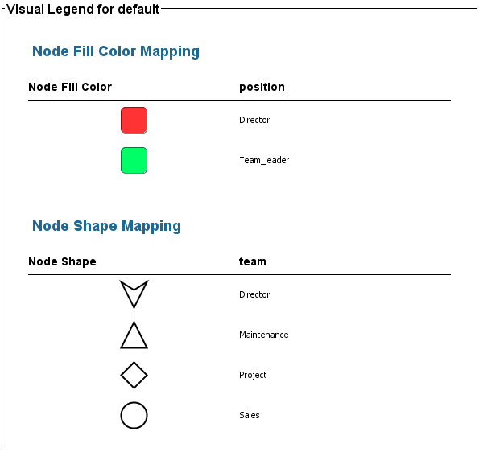

**Observation 1:**

Visualization: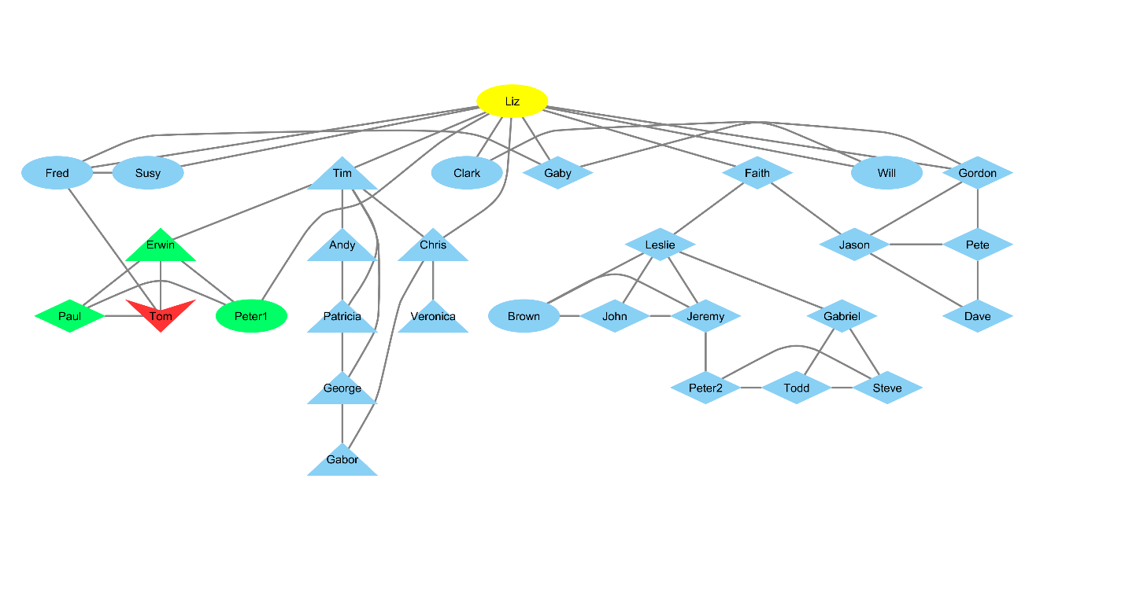



Description: I observed that Liz is placed very high in hierarchical layouts even though she is not a team leader nor is she the director. In the layout shown in the image (yFiles Tree Layout), she is also placed at the topThis is due to her having the most edges in the company out of anyone else, which I think was brought about by her seniority (she has worked here since the company’s foundation – 2001) and her position as a someone in the sales department who needed to communicate with many others in the company. I think identify people like her is important for the CEO since I believe she should have a good grasp of what is happening in the company in every departments with her connections. Since she is not a team leader, she is also able to offer a more standard view of the state of affairs. I also think she can serve as a good communication channel if you want to get support for a new idea (asking her to support your idea might gather more support from normal employees through her network).

Possible algorithm: look for nodes that are placed high in the hierarchy but are not parts of the leadership group (team leaders or director)

**Observation 2:**

Visualization:

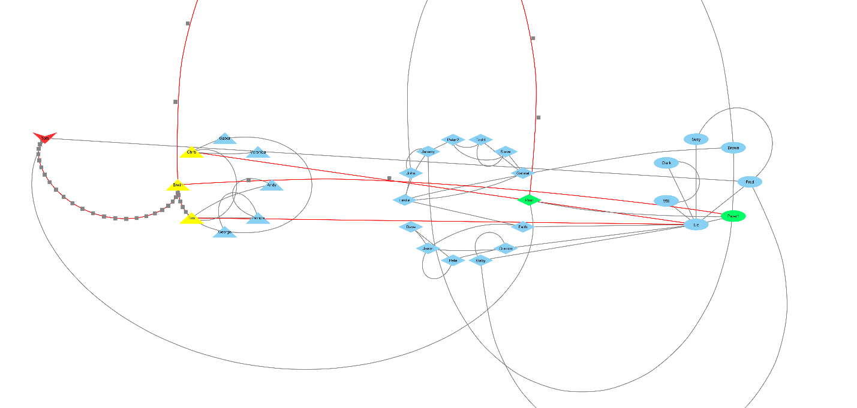

Description: I observed that the maintenance team has very few links/edges with the other teams as shown in the Group Attributes Layout by Team. Specifically, only 3 people (highlighted) from the maintenance team has links with members from other teams. 3/5 edges going out of the maintenance team are edges that connect the team leaders with other team leaders and the director. I think this shows to the CEO that the maintenance team is disconnected from other teams. I believe the company will work better if all the teams are in good relationships with another, hence the CEO should attempt to bring the maintenance team closer to the other teams in the company.

Possible algorithm: look for teams that have the least total outgoing edges to other teams in the network